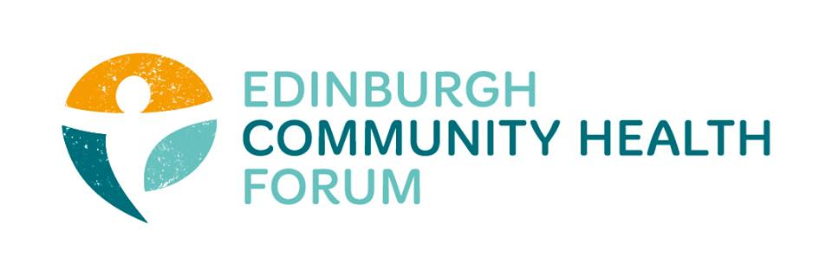
ECHF Forum Meeting
7th March 2019
The Health Agency

Attendees: Charlie Cumming (ELGT), Nancy Bryson (The Beacon Club), Anna Templeton (Dr Bells Family Centre), Moyra Burns (NHS Health Promotion), Linda Arthur (The Health Agency), Helen MacFarlane (Edinburgh Leisure), Kristin Armour (Caring in Craigmillar), Catriona Windle (Health all Round), Iain Stewart (ECF), Helena Richards (Carr Gomm), Magda Czarnecka (Feniks), Michelle Reilly (Streetfit), Stephanie-Anne Harris and Grace Mackenzie (ECHF).
Apologies: Marion Findlay (Volunteer Edinburgh), Biddy Kelly (Fresh Start), Anne Munro (Pilmeny Development Project), Ruth Maclennan (Care4Carers), Michelle Reilly (Streetfit), Anna Templeton (Dr Bells Family Centre), Grace Mackenzie (ECHF), Maruska Greenwood (LGBT Health), Stephanie-Anne Harris (ECHF), Mitra Rostami (Bright Choices), Alison McGhee (Health in Mind), Suzanne Campbell (The Junction), Rachel Green (The Ripple Project)

Tuesday 2nd April – Venue TBC https://www.echf.org.uk/forum-meeting/april-forum-meeting/

