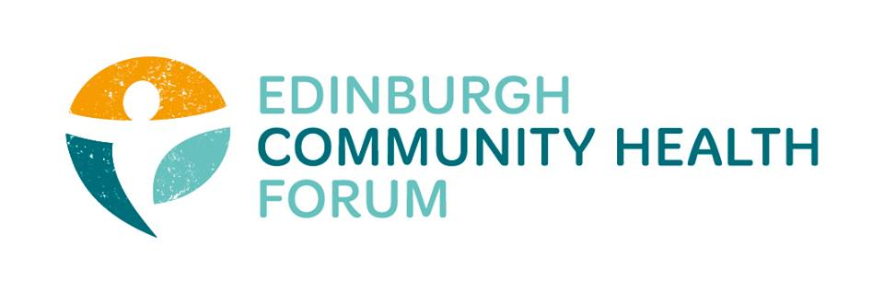
ECHF Forum Meeting
Thursday 4th June via Zoom

Chair:  Stephanie-Anne Harris (ECHF)  Attendees:  Grace Mackenzie (ECHF)  Alex Perry (PCHP/ECHF)  Brock Lueck (One Parent Families Scotland)  Anne Munro (Pilmeny Development Project)  Catriona Windle (Health All Round)  Maruska Greenwood (LGBT Health and Wellbeing)  Nancy Bryson (Beacon Club)  Magda Czarnecka (Feniks)  Charlie Cumming (ELGT)  Georgia Artus (Lifecare Edinburgh)  Helen Tait (Pilton Equalities Project) | Victor Chlebowski (The Murrayfield Club)  Kristin Armour (Phonelink / Caring in Craigmillar)  Helena Richards (CarrGomm)  Marion Findlay (Volunteer Edinburgh)  Emma Cormack (The Health Agency)  Valerie Clark (Harlaw Monday Group)  Dorothy Simpson (The Beacon Club)  John Halliday (Community Renewal)  Brenda Black (Edinburgh Community Food)  Guests:  Ailsa Cook (Matter of Focus)  Liz Simpson (NHS Lothian)  Suzanne Lowden (CEC)

- Matter of Focus (MOF) – Ailsa Cook
We have been working with ECHF for two years now. We have an intuitive evaluation software which and has a narrative approach in order to support you. The central ECHF logic model (which is much less scary than it sounds) allowed us to co host a showcase event in January with the organisations already using the software, which was really well received. See here for more information: https://www.matter-of-focus.com/reducing-health-inequalities-and-improving-long-term-health-outcomes/
At the moment we have three threads of work:
ECHF have secured some regular time with Alex Perry to support the MOF team to interview those who received the COVID19 funding through ECHF (and any others who wish to be involved). The aim is to discover how COVID19 has collectively affected your work. This has been so different for every organisation and it is important not to lose the stories. Normally everyone would evaluate themselves but in order to collect this quickly we will set up the interviews and produce a report. This will also be uploaded into the OutNav software for organisations to use. The strength of a collective story is greater than individually.
Second, we are running workshops to get anyone who would like to use Outnav started, just pass your name to Grace or Stephanie-Anne.
Lastly, for those who are already using Outnav or for training or any furloughed staff, we have twice weekly online clinics on a Tuesday and Thursday and Alex will also be available to have a chat about the practical application side of things, with anyone interested.
- ECHF Update – Stephanie-Anne Harris

Supporting Communities fund. Monies are now into accounts now. As mentioned previously, the reporting is light touch with open dialogue with any changes if required. It is a flexible responsive fund.
AGM. I attended an OSCR webinar on AGM’s and the advice is that it is fine to have this via Zoom even if this is not within your article of memorandum. However it is a good idea to review this to be included going forward. The ECHF AGM will be held at 9am on Mon 24th August. Our guest speaker will be Margaret Douglas who was director of Public Health in Edinburgh and has recently published a BMJ paper on mitigating the health effect of COVID19: https://www.bmj.com/content/369/bmj.m1557
Lastly, I had contact with Angela Lindsay’s team who are working on the mechanism for HSC grants from 2022 and I said it was too early right now to collect any thoughts as everyone is up against it. What she has been looking into is Community Investment, namely the Wigan and Preston models. These are not that different from what we did last time around. I think what need to remain high on the agenda is how we coproduce going forward as the HSCP could certainly not have done this without the community.
- Member Update / Current Issues
Helena Richards (CarrGomm). There are resources via Scottish Government and staff working at Rivers via the Promise website / Here 4 You which are suitable for unpaid carers and volunteers. The COVID19 helpline is also available for anyone working in partnership with Health and Social Care. In addition, on the Carrgomm youtube channel we have some mindfulness and yoga videos very accessible for anyone which are user friendly and short.
- Here4U helpline: 0131 451 7445
- https://www.promis.scot/resource/lothian/
- https://www.promis.scot/organisations/
- https://www.youtube.com/channel/UCZc8zpT0cX1hrLXIbpfFAXQ

Marion Findlay (Volunteer Edinburgh). We have a good supply of volunteers just now is if you need new volunteers for ongoing regular work or to replace people who are flagging. We are able to fasttrack that. For one off things, we have the community task force volunteers up and running now. This was filtered down by screening and induction with 200 ready to be deployed. We have found that people don’t tend to call the central numbers for something local e.g. needing a dog walked. The demand to community groups is higher.
It would be good to hear people’s issues on moving out of lockdown and to prepare guidance around that. Outdoor activities are hoping to restart.
S-AH (ECHF). What do people need help with in coming out of lockdown?
Charlie Cumming (ELGT). We are not able to get hand sanitiser for CEC work.
Catriona Windle (Health All Round). Friends of parks group looking to reopen as long as people bring their own tools. With regards to sanitiser, we got 5 gallon tubs from Holland and Barrett or you could also check https://www.ncworkwear.co.uk/, distilleries may be an option and also worth joining the Edinburgh Coronivrus Support group on facebook. There are around 9000 members and regular offers/ donations.
Helen Tait (PEP). We have a huge barrier as our main activity is day care transport. With distancing guidelines it works out as only 1 person vs 16 on a minibus. At the moment there are no answers to getting our group back.
Kristin Armour (Caring in Craigmillar). We are recruiting to expand our Phonelink team as our numbers have increased. Any service users who would need a call each day the referral process is very easy to set up whether it is a medication prompts, or a chat, this can be daily, twice a week etc. See here: https://caringincraigmillar.co.uk/phonelink-edinburgh.html
Liz Simpson (Health Promotion): Moyra Burns remains on sick leave. We have been working on setting up the new test and protect tracing system, both nationally and locally. Care home support work is going on in the background; this may seem to be quieting down but we can’t be complacent. Work with engagement to find issues to some homelessness e.g. infection control within hostels and looking forward to the re mobilisation phase. A huge effort to look to the post COVID ‘normal’ and to learn lessons about what has worked well.
John Halliday (Community Renewal). Does anyone know if the Digital Inclusion work from Scottish Government (Connecting Scotland) is up and running yet? We were concerned when it came out as it seems to duplicate other work already ongoing.
Maruska Greenwood (LGBTH&W). I received an update that this was being piloted through organisations in Govan and Aberlour.
Emma Cormack (The Health Agency). We are also offering additional counselling, CBT, NLP, check-in calls and groupwork in the South West. People can self-refer by emailing us on hello@thehealthagency.org.uk or leaving name and number 0131 453 9400
Brenda Black (ECF). We continue to work on the food offering, particularly within minority groups. Our initial findings were that there are several levels of difficulty starting with initial engagement, numbers per househould and types of food. We are working in partnership working with NKS to provide food and asking what individuals might want to see in a box as a generic box won’t cut it. We know this group are at risk due to genetics, large households and types of employment. Frustratingly what we have discovered that even the standard government guidelines on healthy eating are not meeting language needs so we are now also doing some work on this. We have also brought many of our learning opportunities online.
- Next meeting
AGM 24th August.

